Project Design Phase-II

Data Flow Diagram & User Stories

|  |  |
| --- | --- |
| Date | 28 June 2025 |
| Team ID | LTVIP2025TMID45878 |
| Project Name | Pattern sense:Classifying Fabric Patterns using Deep Learning |
| Maximum Marks | 4 Marks |

# Data Flow Diagrams:

A Data Flow Diagram (DFD) is a traditional visual representation of the information flows within a system. A neat and clear DFD can depict the right amount of the system requirement graphically. It shows how data enters and leaves the system, what changes the information, and where data is stored.



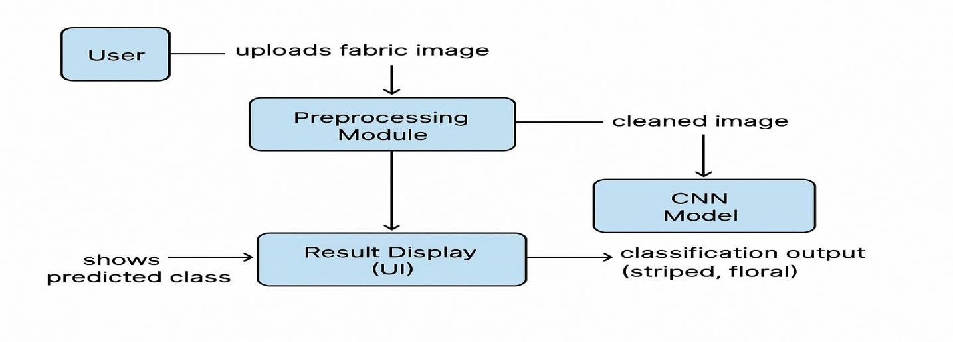

# User Stories

Use the below template to list all the user stories for the product.

|  |  |  |  |  |  |  |
| --- | --- | --- | --- | --- | --- | --- |
| **User Type** | **Functional Requirement (Epic)** | **User Story Number** | **User Story / Task** | **Acceptance criteria** | **Priority** | **Release** |
| Researcher | Upload Image | USN-1 | As a user, I can register for the application by entering my email, password, and confirming my password. | I can access my account / dashboard | High | Sprint-1 |
| System Admin | Preprocess Image | USN-2 | As a user, I will receive confirmation email  once I have registered for the application | I can receive confirmation  email & click confirm | High | Sprint-1 |
| ML Model | Predict Fabric Pttern | USN-3 | As a user, I can register for the application through Facebook | I can register & access the dashboard with Facebook Login | Low | Sprint-2 |
| Researcher | View Prediction  Result | USN-4 | As a user, I can register for the application  through Gmail | Result is visible within 5  seconds of submission | Medium | Sprint-1 |
| System Admin | View log and Performance | USN-5 | As an admin, I can view logs, accuracy metrics, and confusion matrix | Admin dashboard shows logs, accuracy chart | High | Sprint-1 |
|  | Dashboard |  |  |  |  |  |
| Customer (Web user) |  |  |  |  |  |  |
| Customer Care Executive |  |  |  |  |  |  |
| Administrator |  |  |  |  |  |  |
|  |  |  |  |  |  |  |
|  |  |  |  |  |  |  |
|  |  |  |  |  |  |  |